Circuit diagram:

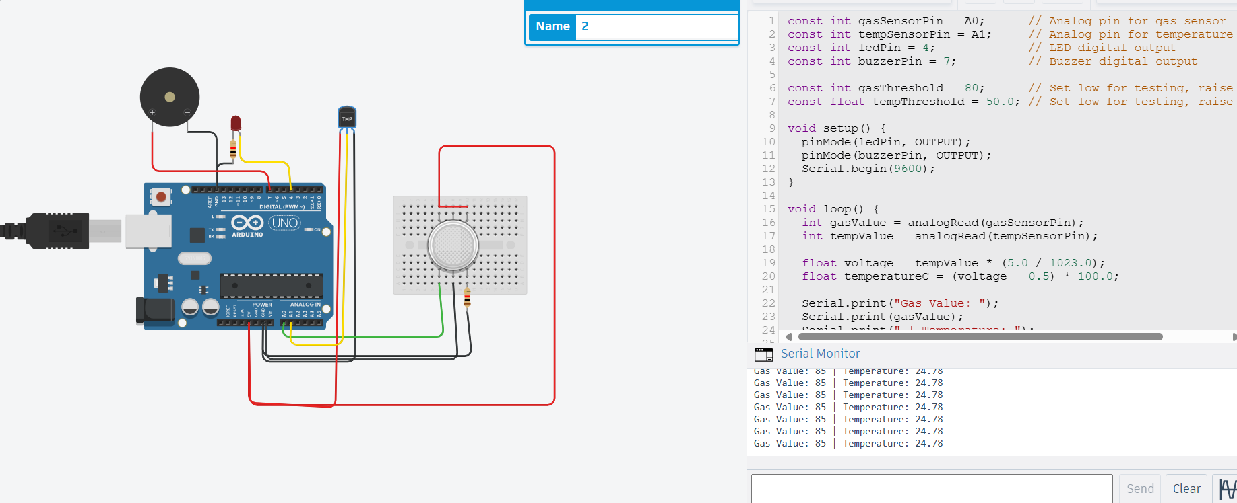

Code:-

const int gasSensorPin = A0; // Analog pin for gas sensor

const int tempSensorPin = A1; // Analog pin for temperature sensor

const int ledPin = 4; // LED digital output

const int buzzerPin = 7; // Buzzer digital output

const int gasThreshold = 90; // Set low for testing, raise for real use

const float tempThreshold = 50.0; // Set low for testing, raise for real use

void setup() {

pinMode(ledPin, OUTPUT);

pinMode(buzzerPin, OUTPUT);

Serial.begin(9600);

}

void loop() {

int gasValue = analogRead(gasSensorPin);

int tempValue = analogRead(tempSensorPin);

float voltage = tempValue \* (5.0 / 1023.0);

float temperatureC = (voltage - 0.5) \* 100.0;

Serial.print("Gas Value: ");

Serial.print(gasValue);

Serial.print(" | Temperature: ");

Serial.println(temperatureC);

// Logic: ON while danger, OFF when safe

if (gasValue > gasThreshold || temperatureC > tempThreshold) {

digitalWrite(ledPin, HIGH); // On

digitalWrite(buzzerPin, HIGH); //On

} else {

digitalWrite(ledPin, LOW); // OFF

digitalWrite(buzzerPin, LOW); // OFF

}

delay(500);

}

Output:-

